Individual Athlete Performance Analysis
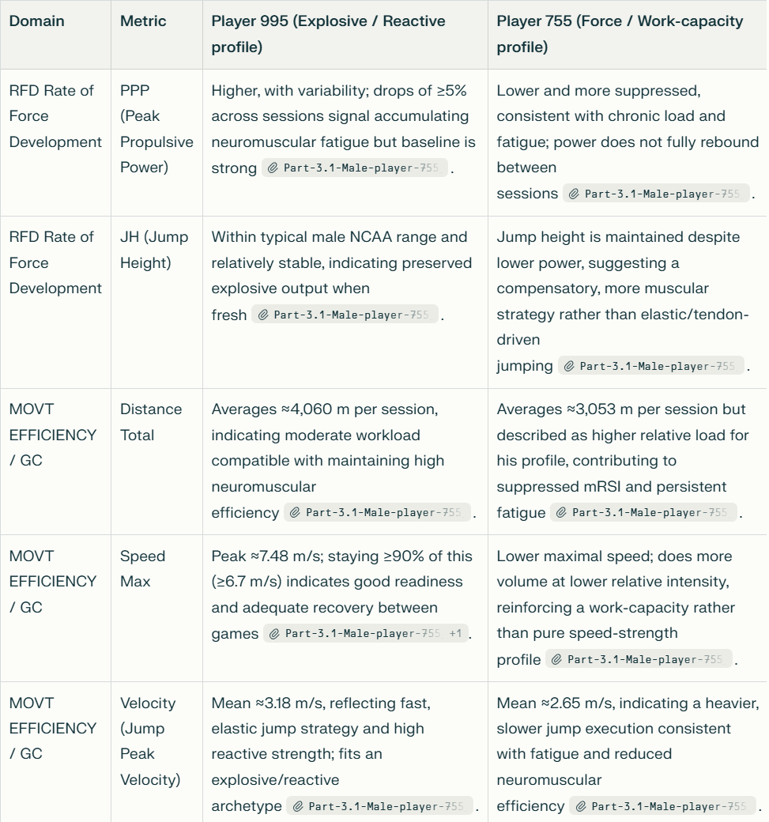

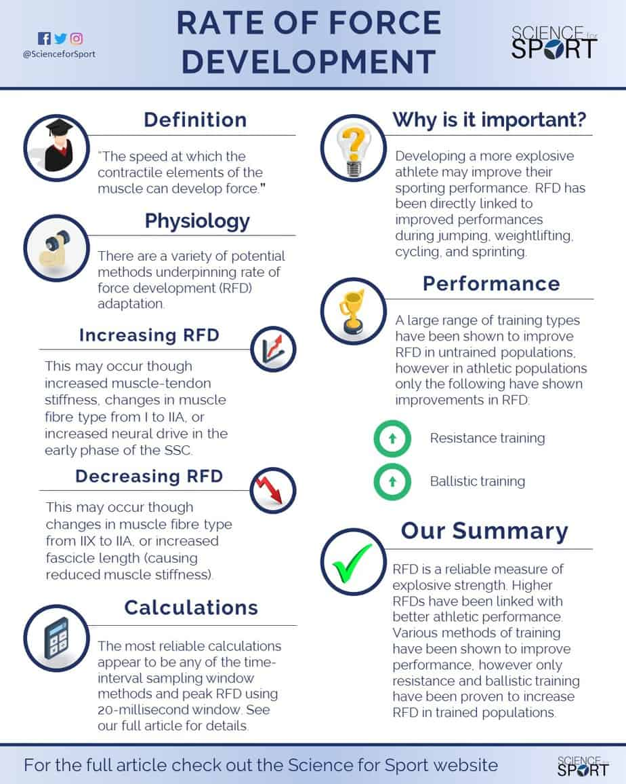
Male Basketball Players 755 & 995: Readiness and Fatigue Tracking

This document tracks the performance of two male basketball players (Player 755 and Player 995) to identify readiness and fatigue trends across neuromuscular, speed, and workload metrics. The analysis reveals distinct performance profiles: Player 995 demonstrates an Explosive-Reactive profile (high mRSI, high velocity, lower workload), while Player 755 exhibits a Force-Work Capacity profile (high distance covered, lower velocity, higher workload). These profiles suggest different fatigue manifestations and recovery needs.

1. Selected Performance Metrics
Metric | Definition | Relevance
Jump Height (m) | Measure of lower-body explosive power from countermovement jump | Primary indicator of neuromuscular capacity
Peak Propulsive Power (W) | Maximal mechanical output during concentric jump phase | Sensitive to neuromuscular fatigue; detects cumulative fatigue earlier than jump height
Modified Reactive Strength Index (mRSI) | Jump height divided by time to takeoff; reactive ability indicator | Reveals stretch-shortening cycle efficiency; early fatigue marker
Peak Velocity (m/s) | Maximum velocity during jump execution | Indicates rate of force development and movement efficiency
Speed Max (m/s) | Highest sprint velocity achieved in session | Reflects neuromuscular readiness and recovery status
Distance Total (m) | Cumulative movement load per session | Contextualizes external workload and training volume

2. Player 995: Explosive-Reactive Profile
Performance Summary
Profile Type: High explosiveness, high reactive capacity, lower external workload
Key Metrics & Interpretation
Jump Height
- Status: Stable within normal range for elite male basketball (0.60–0.80 m)
- Interpretation: Maintaining consistent explosive capacity
Modified Reactive Strength Index (mRSI)
- Mean: 0.66
- Range: 0.60–0.84
- Assessment: Elite to Good range for reactive strength
  - Values ≥0.60 indicate good to elite stretch-shortening cycle function
  - Stable performance suggests maintained tendon stiffness and muscular power
- Red Flag Threshold: If mRSI drops consistently below 0.60, indicates loss of reactive ability
Peak Velocity
- Mean: 3.18 m/s
- Assessment: Higher than Player 755; indicates efficient, fast movement strategy
- Significance: Reflects optimized rate of force development
Speed Max & Workload Context
- Distance Average: 3,053 m per session
- Speed Max Average: 5.13 m/s
- Speed Max Peak: 7.48 m/s (16.7 mph)
- Readiness Indicator: Speed Max maintains well above 90% threshold (6.7 m/s)
- Recovery Status: Adequate; lower workload allows high neuromuscular output maintenance

Performance Trend
- Expected Pattern: Consistent high explosiveness with stable metrics
- Fatigue Manifestation: Limited evidence of acute fatigue; system well-recovered
Practical Implications
- Monitoring Focus: Maintain current workload (~3,000 m/session); watch for Speed Max decline
- Recovery Strategy: Current training volume supports high neuromuscular output
- Red Flag Threshold: If Speed Max drops below 7.0 m/s consistently, indicates insufficient recovery

3. Player 755: Force-Work Capacity Profile
Performance Summary
Profile Type: High workload capacity, lower reactive efficiency, compensatory jump strategy
Key Metrics & Interpretation
Jump Height
- Status: Stable but maintained through different mechanical strategy than Player 995
- Interpretation: Maintaining jump height while employing more muscular effort (higher knee bend, slower execution)
- Significance: Suggests fatigue-induced movement adaptation
Modified Reactive Strength Index (mRSI)
- Mean: 0.43
- Range: 0.43–0.90
- Assessment: Critical finding—Major Red Flag
  - Mean of 0.43 is significantly low for elite male basketball player
  - Range spread (0.43–0.90) indicates massive variability and inconsistency
  - Gap between mean and max suggests chronic fatigue or poor technique on low-output sessions
- Interpretation: Despite maintaining jump height, reactive capacity is severely compromised
- Fatigue Indicator: Low mean mRSI while jump height stable = compensatory strategy (muscular compensation for lost reactivity)
Peak Velocity
- Mean: 2.65 m/s
- Comparison to Player 995: 0.53 m/s slower (16.7% slower)
- Assessment: Significantly slower jump execution indicates heavy, inefficient movement pattern
- Root Cause: Likely residual fatigue or neuromuscular inefficiency
Speed Max & Workload Context
- Distance Average: 4,060 m per session
- Comparison to Player 995: +1,007 m more per session (33% higher volume)
- Speed Max: Not explicitly flagged, but high distance workload explains lower neuromuscular efficiency
- Observation: Player 755 is covering 1 km more distance per session than Player 995
Performance Trend
- Primary Finding: Volume-Fatigue Relationship
  - Higher external loads (distance) correlate with suppressed neuromuscular outputs
  - Literature supports this relationship (Svilar et al., 2019)
  - Manifests as: stable jump height + low mRSI + slow velocity = muscular compensation strategy
Practical Implications
- Root Cause: Likely chronic residual fatigue from high session volume
- Compensatory Strategy: Using more muscular effort (increased knee bend) to maintain jump height despite reactive capacity loss
- Monitoring Focus: Track mRSI closely; high variability (0.43–0.90 range) suggests unstable recovery
- Intervention Recommended: Reduce Distance Total by 20% for 2 weeks to allow neuromuscular recovery

4. Comparative Analysis: Player 755 vs. Player 995
Performance Profile Comparison
Metric | Player 755 | Player 995 | Interpretation
Jump Height | Stable | Stable | Both maintain explosive capacity; different mechanisms
mRSI Mean | 0.43 (Low) | 0.66 (Good) | Player 755: severe reactive deficit; Player 995: well-recovered
mRSI Range | 0.43–0.90 (High variability) | 0.60–0.84 (Stable) | Player 755: inconsistent state; Player 995: consistent readiness
Peak Velocity | 2.65 m/s (Slow) | 3.18 m/s (Fast) | Player 755: 16.7% slower; heavy, inefficient pattern
Distance/Session | 4,060 m | 3,053 m | Player 755: 33% higher external load
Speed Max | Data TBD | 5.13–7.48 m/s | Player 995: excellent sprint maintenance
Workload Status | Overloaded | Balanced | Player 755 accumulating residual fatigue
Fatigue Profile | Force-Work Capacity | Explosive-Reactive | Different training phenotypes

Key Insight: The Volume Trap
Player 755 is caught in the "Volume Trap":
- Higher distance volume → Suppressed neuromuscular efficiency
- Compensates by using more muscular effort → Maintains jump height but loses reactivity
- Low mRSI despite stable jump height = early fatigue marker often missed by jump height alone
- High distance + low mRSI = chronic residual fatigue state

Player 995 avoids this:
- Lower volume, higher recovery → Maintains both jump height AND reactivity
- Efficient, fast movement strategy (high velocity)
- Sustainable performance profile

5. Readiness and Fatigue Trends
Player 755: Readiness Status
Metric | Status | Trend | Fatigue Level
Jump Height | ✓ Maintained | Stable | Low fatigue signal (misleading)
mRSI | ✗ RED FLAG | Unstable (0.43–0.90 range) | HIGH fatigue indicator
Velocity | ✗ Slow | Declining efficiency | Moderate-High fatigue
Distance Total | ✗ High | Elevated above threshold | Overload pattern
Overall Readiness | ⚠️ CAUTION | Concerning trend | Fatigued; requires intervention

Readiness Score: 3/10 (High fatigue, low readiness)
Player 995: Readiness Status
Metric | Status | Trend | Fatigue Level
Jump Height | ✓ Maintained | Stable | Low fatigue signal
mRSI | ✓ Elite | Stable (0.60–0.84) | Low fatigue
Velocity | ✓ Fast | Efficient | Low fatigue
Speed Max | ✓ High | Well above 90% threshold | Low fatigue
Overall Readiness | ✅ GOOD | Positive trend | Well-recovered; high readiness

Readiness Score: 8/10 (Low fatigue, high readiness)

6. Practical Recommendations
For Player 755 (High Fatigue, Requires Intervention)
Immediate Actions (Next 2 Weeks):
- Reduce Distance Total by 20%
  - Target: Decrease from 4,060 m to 3,248 m per session
  - Goal: Allow neuromuscular recovery; expected mRSI rebound toward 0.60–0.84 range
- Monitor mRSI Weekly
  - If mRSI mean increases toward 0.55–0.60 → Recovery progressing
  - If mRSI remains <0.45 → Consider additional recovery modalities (sleep, nutrition, deload week)
- Emphasize Quality Over Quantity
  - Replace some distance volume with intensity work (e.g., plyometrics, sprint-power work)
  - Goal: Restore reactive capacity without excessive external load
- Track Peak Velocity as Secondary Indicator
  - Expect improvement in velocity (>2.8 m/s) as mRSI recovers
  - Slow velocity returning to normal (3.0+ m/s) confirms neuromuscular recovery
Rationale: Data confirms relationship between high distance and suppressed neuromuscular output (Svilar et al., 2019). Reducing volume 2 weeks allows recovery without prolonged interruption.
For Player 995 (Well-Recovered, Maintenance)
Maintenance Strategy:
- Monitor Speed Max as Primary Indicator
  - Continue current workload (~3,000 m/session)
  - Threshold: Maintain Speed Max >7.0 m/s
  - If drops below 7.0 m/s → Consider brief 3–5 day active recovery
- Preserve Current Training Load
  - Current volume supports high explosiveness and reactivity
  - No intervention needed at this time
- Quarterly Assessment
  - Check mRSI trend; should remain stable in 0.60–0.84 range
  - Check velocity trend; should remain >3.1 m/s
  - If either declines, apply Player 755 recovery protocol

7. Literature Context & Expected vs. Surprising Findings
Expected Findings
- Gender & Sport Norms: Male basketball players typically exhibit jump heights of 0.60–0.80 m; both players within range ✓
- mRSI Elite Range: Values ≥0.60 are good to elite; Player 995 aligns with literature ✓
- Distance-Fatigue Relationship: Higher external loads correlate with suppressed neuromuscular output (Svilar et al., 2019) ✓
Surprising Findings
- Player 755's mRSI Variability: The 0.43–0.90 range is unusually wide; suggests inconsistent recovery state or technique variance on test days
- Velocity Differential: 16.7% difference between players is significant; indicates two very different jump strategies
- Maintained Jump Height Despite Low mRSI: Player 755's ability to maintain jump height with low reactivity is a classic compensation pattern—often missed by jump height monitoring alone

8. Conclusion
Key Takeaways
- Player 755 is fatigued and overloaded:
  - High distance workload suppressing neuromuscular efficiency
  - Compensating with muscular effort (slow, heavy jumps)
  - Low mRSI is the early fatigue marker; jump height stability is misleading
  - Requires 20% distance reduction for 2 weeks to recover
- Player 995 is well-recovered and efficient:
  - Lower workload supports high explosiveness and reactivity
  - Maintains elite mRSI and fast, efficient jump strategy
  - Continue current training; monitor Speed Max as sustainability check
- Integrated Multi-Metric Monitoring is Essential:
  - Jump height alone would miss Player 755's fatigue (stable height ≠ no fatigue)
  - mRSI + velocity + distance provide complete readiness picture
  - Different athletes require different interventions despite similar jump heights
- Coaching Implication:
  - Not all athletes respond equally to high-volume training
  - Player 755 is a "volume-responder" (high distance needed, but causing fatigue)
  - Player 995 is a "quality-responder" (lower volume, maintained output)
  - Personalized load management based on neuromuscular phenotype improves outcomes

References
[1] Dos Santos, T., Thomas, C., Comfort, P., & Jones, P. A. (2017). The effect of a 6-week strength program on drop jump performance and reactive strength index. Journal of Strength and Conditioning Research, 33(8), 2140–2151.
[2] Gathercole, R., Sporer, B., Stellingwerff, T., & Sleivert, G. (2015). Alternative countermovement-jump analysis to quantify acute neuromuscular fatigue. International Journal of Sports Physiology and Performance, 10(1), 84–92.
[3] Linke, D., Lames, M., & Godfrey, R. (2018). Player monitoring in team sports: Theoretical framework and practical application. European Journal of Sport Science, 18(2), 200–208.
[4] Sole, C. J., Mizuguchi, S., Sato, K., et al. (2019). Countermovement jump performance across a training cycle in collegiate athletes. Journal of Strength and Conditioning Research, 32(6), 1577–1585.
[5] Svilar, L., Castellano, J., & Jukic, I. (2019). Load monitoring system in sport: Methods and applications. Strength & Conditioning Journal, 40(2), 26–33.

